**PROCESS TO IMPLEMENT ODM RULES**

**Step 1: Start Rule Designer**

From the **Start** menu, click **Programs\IBM\Operational Decision Manager V8.5.1\RuleDesigner**

NOTE: Before creating rule project you need to create a pojo class

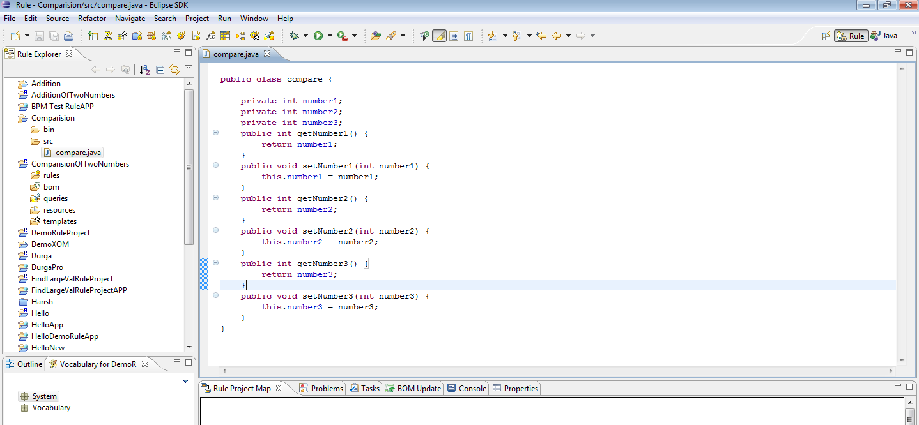

**Step 2: Create a rule project**

To create the rule project:

1. Make sure that you are in the **Rule** perspective.

**Tip:** To switch to the Rule perspective, click the **Window** menu, click **Open**

**Perspective** > **Other**, then select **Rule**, and then click **OK**.

2. Click **File** > **New** > **Rule Project**.

3. Select **Standard Rule Project** and click **Next**.

4. In the **Project name** field, type ***ComparisionOfTwoNumbers***

5. Click **Finish**.

*ComparisionOfTwoNumbers* project opens in the Rule Explorer, and the Rule Project Map is now active.

**Step 3: Attach the Java project**

Now that you have an empty rule project, you can use the Rule Project Map to

guide you through the steps of building the project.

To import the execution object model (XOM) into your rule project:

1. In the Rule Explorer, click my rule project to select it.

The Rule Project Map displays the steps to follow to design your rule project.

2. In the Design part of the Rule Project Map, click **Import XOM**.

3. In the Import XOM dialog, select **Java Execution Object Model** and click **OK**.

4. Under **Required Java projects**, select ***Comparision***.

5. Click **OK**.

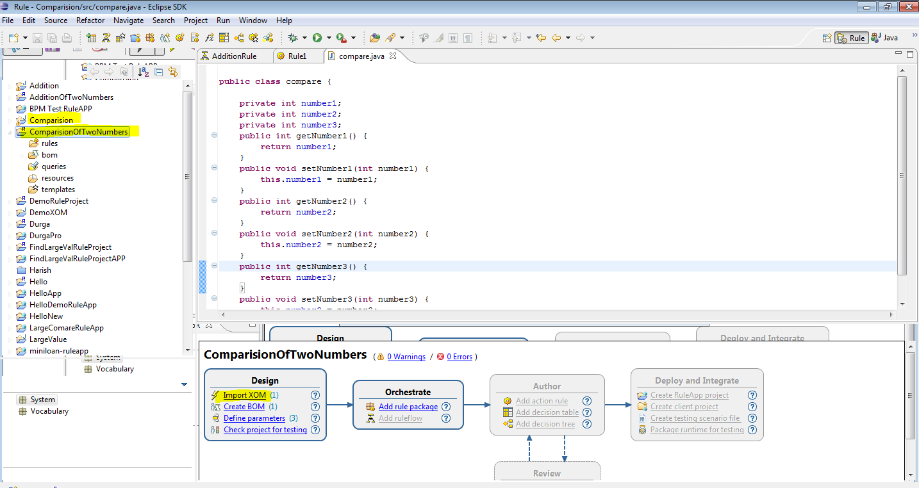

**Step 4: Create the BOM**

Before you create and edit rules, you need to define a business object model

(BOM). You can create a BOM from scratch or create it automatically by parsing

your execution object model (XOM).

Here you use Rule Designer to parse your Java classes (XOM) automatically and

create the BOM from their methods and properties. Then, you can write rules from

the vocabulary terms that are contained in the BOM.

To create a BOM from the XOM:

1. In the Design part of the Rule Project Map, click **Create BOM**.

**Tip:** You can also right-click the bom folder in the Rule Explorer and click

**New** > **BOM Entry**.

2. In the New BOM Entry wizard, in the **Name** field, type Compare.

3. Make sure that **Create a BOM entry from a XOM** is selected, and then click

**Next**.

4. In the **Choose a XOM entry** field, click **Browse XOM**, select

platform:/Comparision, and then click **OK**.

5. Under **Select classes**, select the Add package. Selecting the package

selects all the classes in the package.

6. Click **Next**.

7. In the BOM Verbalization page, you must select the **All Methods** check box.

This ensures that all methods are verbalized in compare to the elements

already selected.

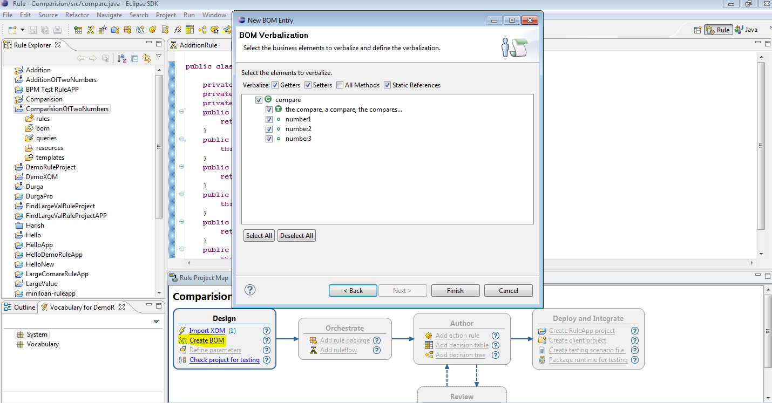

**Step 5: Declare ruleset parameters**

To declare ruleset parameters:

1. In the Design part of the Rule Project Map, click **Define parameters**.

**Tip:** You can also right-click the my rule project project in the Rule Explorer

and click **Properties**.

2. In the Properties dialog, make sure that **Ruleset Parameters** is selected.

3. To define the borrower parameter, click **Add**.

A new row is displayed with default values. Change the values as follows:

a. In the **Name** column, type number1.

b. Click the cell in the **Type** column, click the **...** button to display the Types

dialog, and then double-click the **integer** type in the Matching types box.

The integer type is displayed in the **Type** column.

c. In the **Direction** column, select the **IN** direction.

d. In the **Verbalization** column, type the mynum1.

4. To define the second parameter, click **Add**.

a. In the **Name** column type number2.

b. Click the cell in the **Type** column, click the **...** button to display the Types

dialog, and then double-click the **Integer** type in the Matching types box.

The integer type is displayed in the **Type** column.

c. In the **Direction** column, keep the default **IN** direction.

d. In the **Verbalization** column, type the Mynum2.

5.To define the Third parameter, click **Add**.

a. In the **Name** column type number3.

b. Click the cell in the **Type** column, click the **...** button to display the Types

dialog, and then double-click the **Integer** type in the Matching types box.

The integer type is displayed in the **Type** column.

c. In the **Direction** column, keep the default **OUT** direction.

d. In the **Verbalization** column, type the Mynum3.

Your ruleset parameters are displayed as follows:

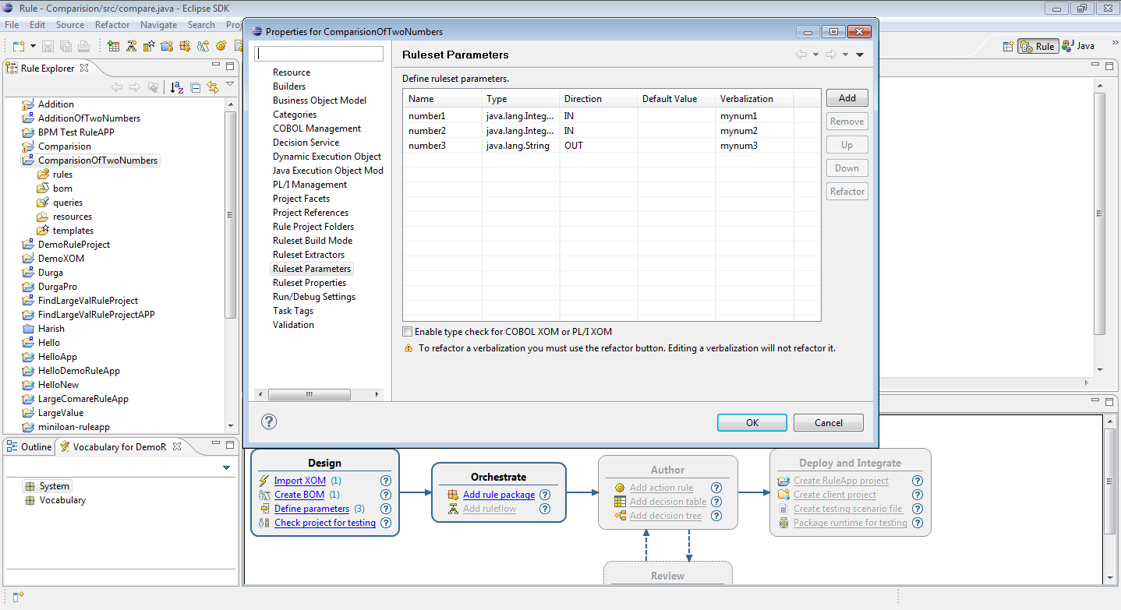

6. Click **OK** to save.

**Step 6: Create rule packages**

To create a rule package:

1. In Rule Designer, in the Orchestrate part of the Rule Project Map, click **Add**

**rule package**.

**Tip:** You can also right-click the my rule project/rules folder in the Rule

Explorer and click **New** > **Rule Package**.

2. In the New Rule Package wizard, enter **com.compare** in the **Package** field, and

then click **Finish**.

The new validation rule package opens in the Rule Explorer.

**Step 7: Create the ruleflow diagram**

**Create an action rule:**

To create an action rule:

1. In Rule Designer, in the Author part of the Rule Project Map, click **Add action**

**rule**.

**Tip:** You can also right-click the validation package in the Rule Explorer and

click **New** > **Action Rule**.

2. In the **Package** field, type com.compare (or click **Browse** to select it) and in the

**Name** field, name the rule **rule1**.

3. Click **Finish**.

The Intellirule editor opens.

**Complete the action rule**

You now use the code completion mechanisms of the Intellirule Editor to help you

create the rule.

To complete the action rule:

1. In the Intellirule editor, type if, and then press the space bar. The Content

Assist box opens:

Select terms and phrases from the Content Assist box to build the expression.

2. On the next line, type then, press the space bar, and then press

**Ctrl+Shift+space** bar to activate the Tree Completer.

**Important:**

You must include a semicolon (;) at the end of the line.

3. Press **Esc** after entering the semicolon, if you are still in the Content Assist box.

4. Press **Ctrl+Shift+F** to format the rule.

Your rule should now be:

***if***

**'my num1'** is more than **'my num2'**

***then***

**set** **'my num3'** **to** **"Number1 is greater than Number2"** ;

***else***

**set** **'my num3'** **to** **"Number1 is less than Number2"** ;

5. Save your work and close the Intellirule editor.

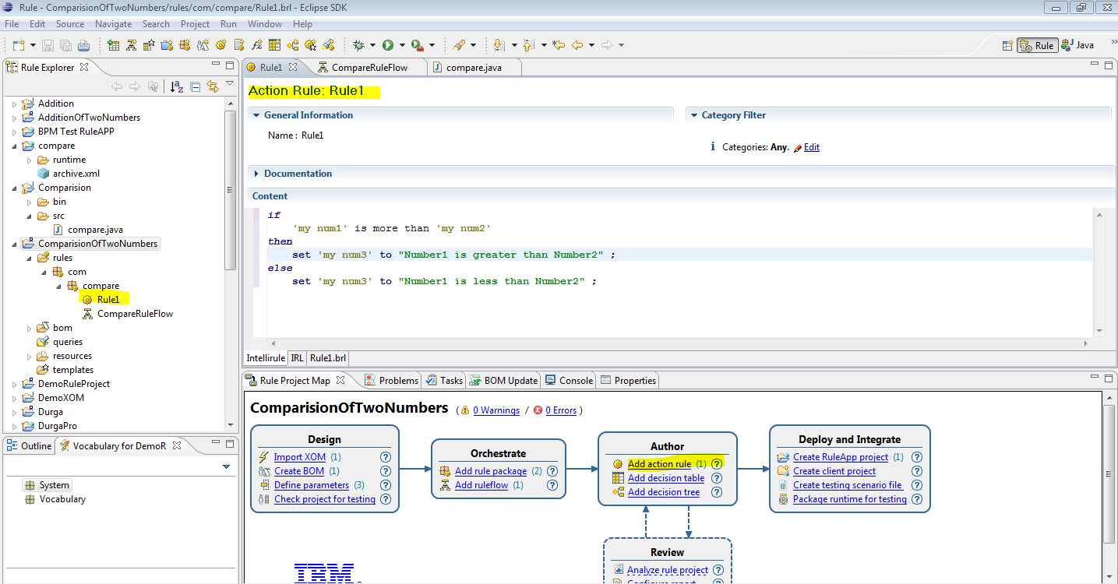

**Create the RuleFlow:**

To create a ruleflow:

1. In the Orchestrate part of the Rule Project Map, click **Add ruleflow**.

**Tip:** You can also right-click the ComparisionOfTwoNumbers/rules folder in the Rule

Explorer and click **New** > **Ruleflow**.

2. In the New Ruleflow wizard, make sure that the **Source folder** field is set to

/ComparisionOfTwoNumbers/rules, and that the **Package** field is **com.compare**

3. In the **Name** field, type CompareRuleFlow.

4. Click **Finish**.

The ruleflow editor opens, and enables you to construct the flow of tasks

graphically. You specify how tasks are chained together: how, when, and under

what conditions they will be executed.

5. Click **Create a start node** and then click in the ruleflow editor.

The ruleflow start node is displayed in the ruleflow editor.

6. Click **Create an end node** and then click in the ruleflow editor.

You now have a start node and an end node for your ruleflow.

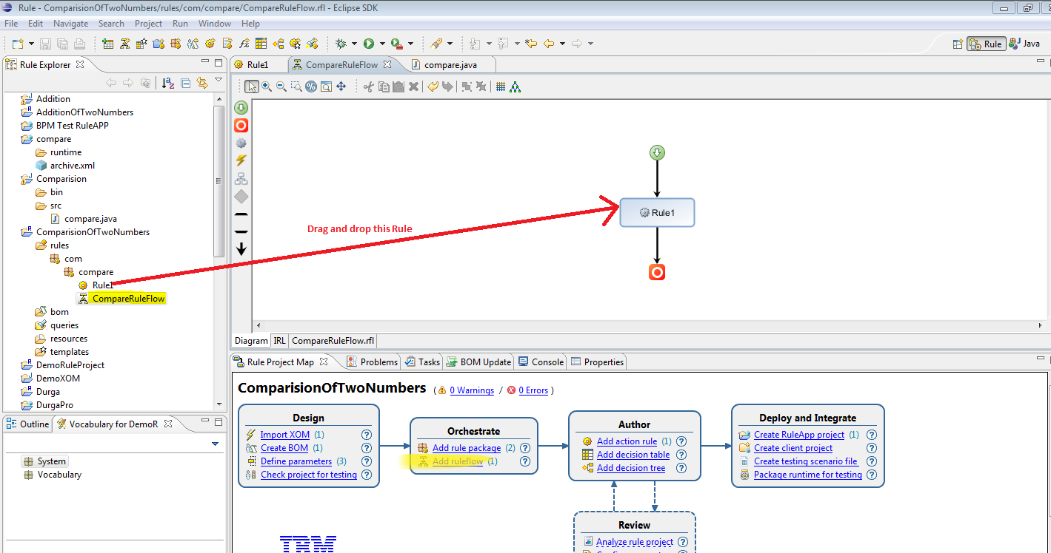

**Deploying rules**

In this task, you deploy your ruleset to Rule Execution Server. Rule Execution

Server is the runtime environment that contains the rule engine to execute the

rules

**Deploy from Rule Designer**

To deploy the rules from Rule Designer, you must first create a RuleApp project.

Then, you set some properties to enable the monitoring of the ruleset execution

that you will do in the next task.

To create a RuleApp project and deploy the RuleApp:

1. Make sure that the sample server is started.

2. In the Deploy and Integrate part of the Rule Project Map, click **Create**

**RuleApp project**.

**Tip:** You can also use the **File** menu, then click **New** > **Project** and select **RuleApp Project**.

3. In the New RuleApp Project wizard, in the **Project name** field, type **CompareRuleApp**.

4. Click **Next**.

The ComparisionOfTwoNumbers project is displayed on the Add Ruleset Archives page.

**Tip:** If you cannot see your rule project, click **Add**, select ComparisionOfTwoNumbers project,

and click **OK**.

5. Click **Finish**.

You created a RuleApp project that contains a ruleset archive generated from

the project ComparisionOfTwoNumbers project.

**CompareRuleApp** is displayed in the Rule Explorer and the RuleApp editor opens to

let you deploy the RuleApp to Rule Execution Server.

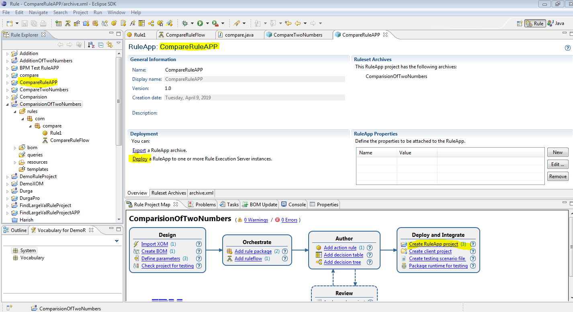

6. Click the **Overview** tab, and click **Deploy** in the Deployment section.

7. In the Deploy RuleApp Archive wizard, keep **Increment RuleApp major**

**version** selected, and click **Next**.

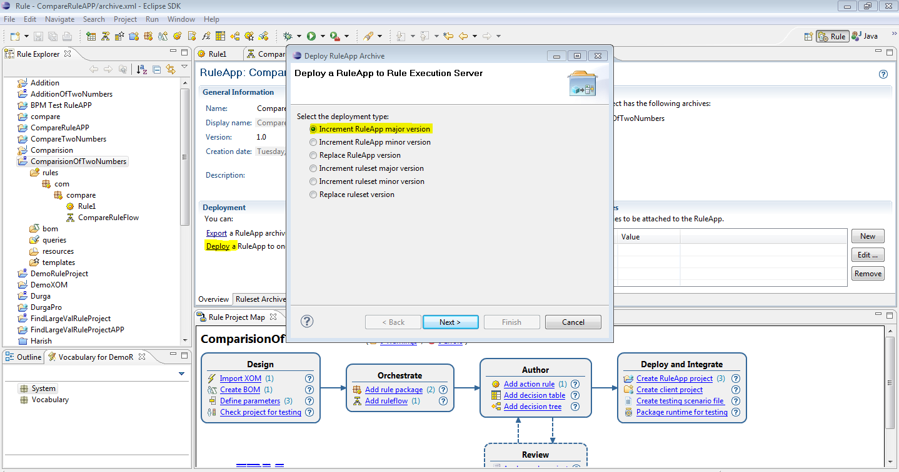

**Note:** A warning is displayed if you are using the default Eclipse with JDK 7.

If your application server runs with JDK 6, you must modify the settings in

Eclipse to use JDK 6.

8. On the next wizard page, make sure that **Create a temporary Rule Execution**

**Server configuration** is selected, and type the following configuration details:

**URL**: http:// bandaru1-anil-PC:9083/res

**Important:** Enter the correct port number in the URL. For more information,

see Checking the server port number.

**Login**: odmadmin

**Password**: *******

9. Click **Finish**.

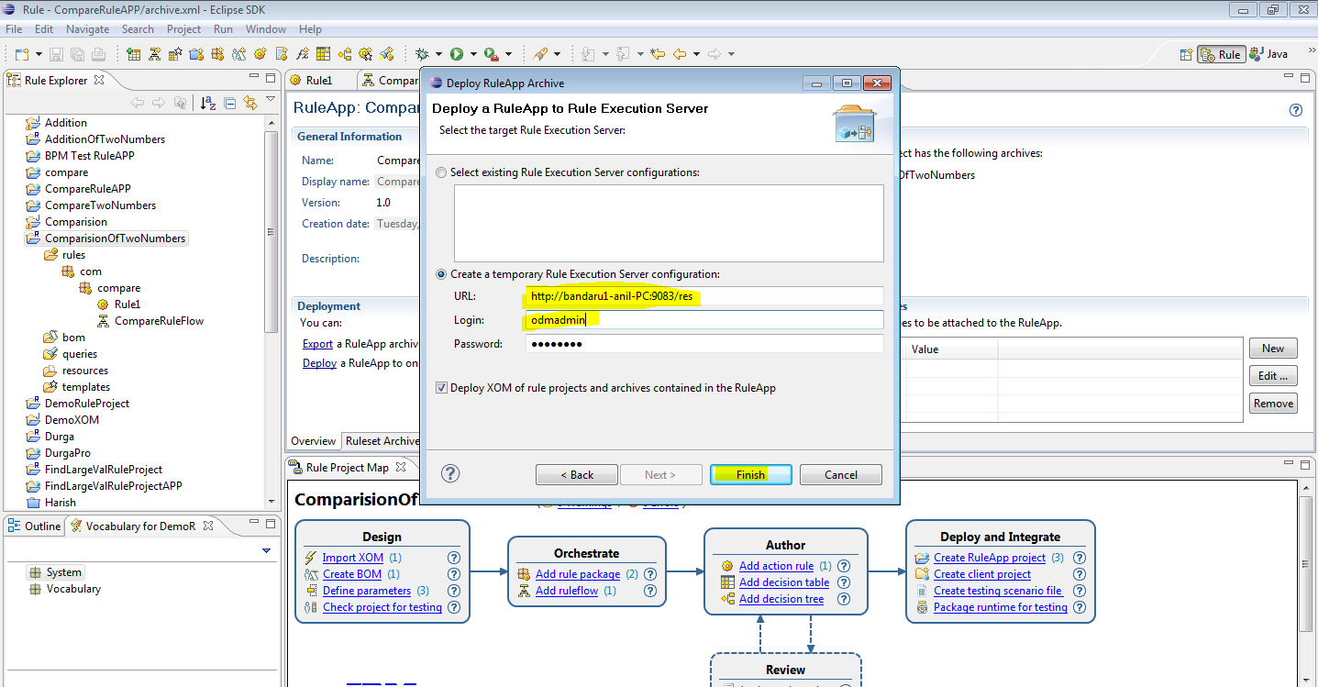

The Console displays a message indicating that the 1.0 version of the RuleApp

has been deployed.

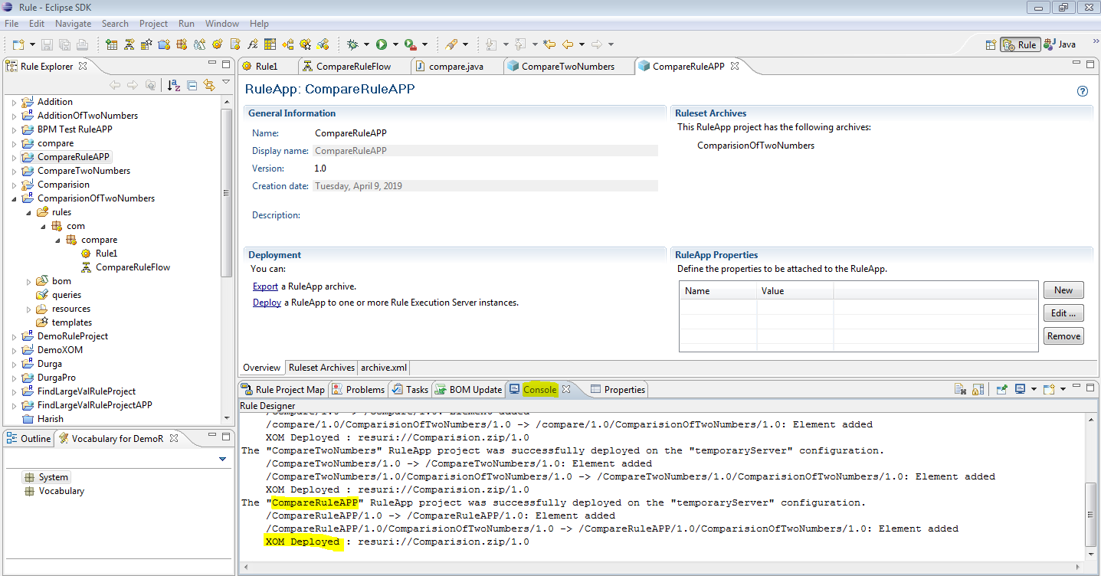

10. Close the RuleApp editor.

**View the deployed RuleApp**

You now view the deployed RuleApp in Rule Execution Server, which is an

execution environment for rules (Java SE and Java EE) that interacts with the rule

engine. Rule Execution Server handles the management, performance, security, and

logging capabilities associated with the execution of your rules.

To view the deployed RuleApp:

1. Click **Start** > **All Programs** > **IBM** > ***package_group*** > **Sample Server** > **Rule**

**Execution Server Console**.

*package_group* refers to the package group specified in IBM Installation Manager

during installation. The default package group is Operational Decision Manager

V8.5.1.

**Tip:** You can also enter ***http:// bandaru1-anil-PC:9083/res*** in a browser. Enter the

correct port number for the URL.

2. Sign in to the Rule Execution Server console using the following details:

**Username**: odmadmin

**Password**: *******

3. Click the **Explorer** tab.

4. In the Navigator, expand **RuleApps**, and then / CompareRuleApp /1.0.

You see that Rule Execution Server contains your 1.0 version of ComparisionOfTwoNumbers,

which contains the 1.0 version of the ruleset as expected:

5. Click / ComparisionOfTwoNumbers /1.0 to view the details of the ruleset in the Ruleset View.

Note that the status of the ruleset is **enabled**, indicating that it can be executed.

6. Click the **Show Properties** link to view the ruleset properties.

The property that you added in the previous step is set to true.

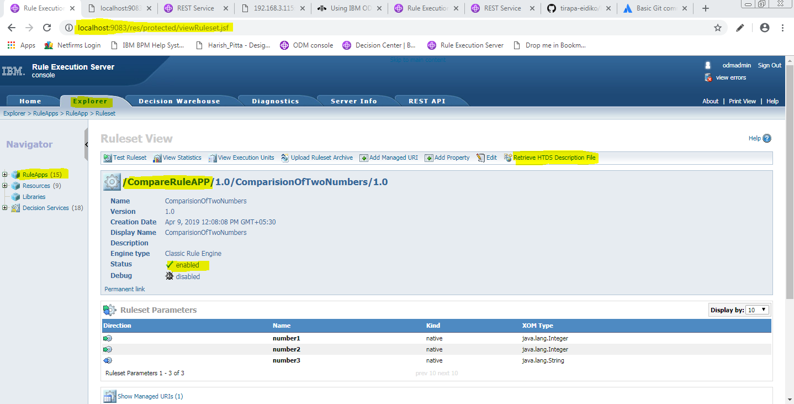

**Retrieve the HTDS WSDL file**

A hosted transparent decision service (HTDS) is a web service that provides an

interface to access a deployed ruleset. The Decision Service component passes

input parameters to the rule engine and accesses the return values. The transparent

decision service support includes traceability from decision services to rules,

runtime monitoring and version management.

You can retrieve the WSDL file for the ComparisionOfTwoNumbers ruleset, from the Rule

Execution Server console.

To retrieve the WSDL file:

1. In the Rule Execution Server console, make sure that you are still on the

myruleproject ruleset page, and click **Retrieve HTDS Description File** in the

toolbar at the top.

2. Keep the **SOAP/Rest** option selected, and then select **Latest ruleset version** and

**Latest RuleApp version**, and click **View**.

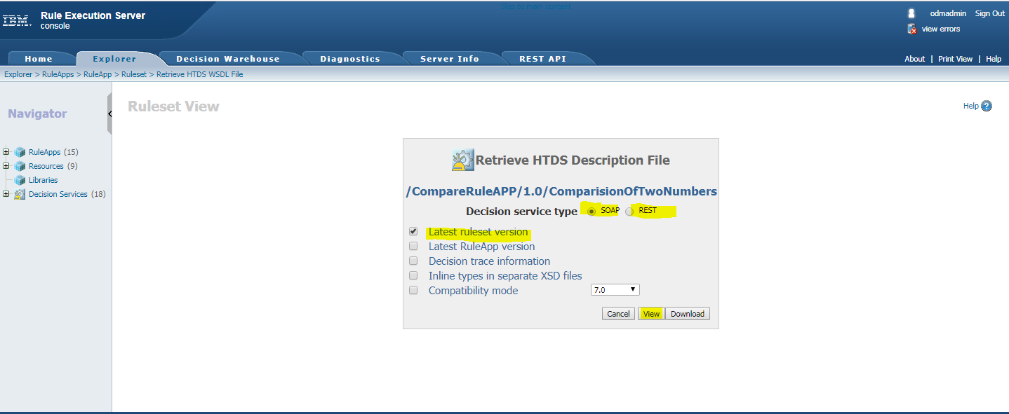

**IBM Operational Decision Manager**

You can call IBM® Operational Decision Manager decision services in IBM Business Process Manager as a SOAP web service or by using OpenAPI and REST. The instructions in this topic describe **how to call** **IBM ODM decision services by using OpenAPI**.

To configure the server:

1. Under **Process App Settings** click **Server**.
2. For the server type, select **IBM Decision Server**.
3. For **Host name**, specify the hostname of the IBM ODM server

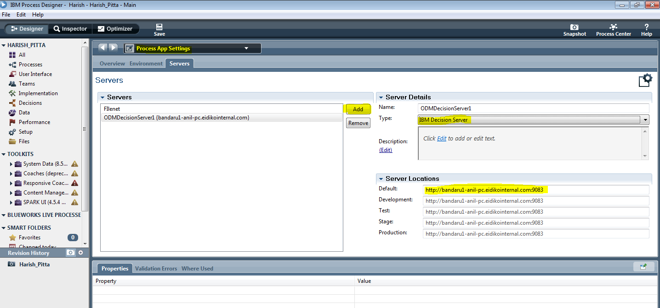

**You can now use the external service in a service flow.**

In web Process Designer:

1. Create a service flow.
2. Use a Jrules Decision Service to invoke an operation of the external service.
3. For **Implementation**, specify the external service.

* Select the server you configured in **Process App Settings**.
* Give a SOAP port number of ODM Server
* Give Username and Password of ODM Server
* Click On **Connect** button it will show all RuleAppProjects available in Rule Execution Server.

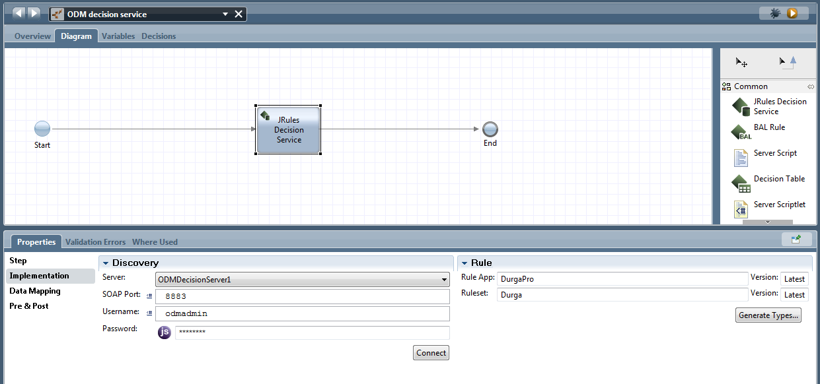

1. For **Operation**, select the operation to use.
2. Specify data mappings as required by the operation.

